About Lisina M. Hoch

For more than 50 years, Lisina M. Hoch, together with her late husband, Frank, has been a major benefactor to a wide array of local and international socially responsible organizations. Her long record of philanthropy as a leader, volunteer and donor spans the globe. The Westchester Children’s Museum is honored to be counted among the organizations that she has supported, and in our case, helped propel to success.

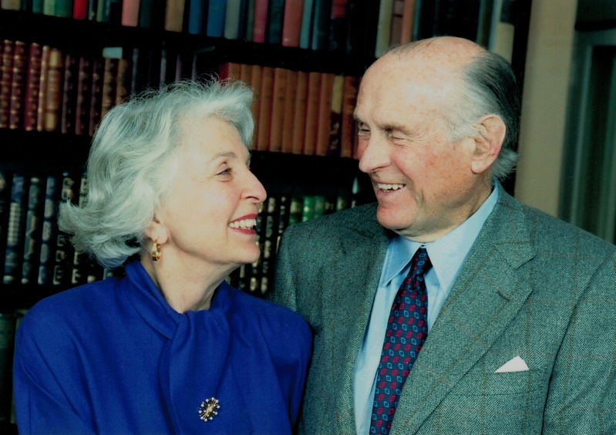
Mrs. Hoch, who lives in Irvington, is one of the Museum’s most generous and longstanding donors, having supported the initiative to build a children’s learning center in Westchester since its founding in 2001. Mr. and Mrs. Hoch’s attention to the Westchester Children’s Museum was drawn by their daughter Alix Laager, a founding boardmember.

Mrs. Hoch is very engaged in organizations that sustain and protect the environment both locally and globally. She is a member of the Irvington Chapter of the American Garden Club and serves as a board member of Scenic Hudson, Woods Hole Oceanographic Institute, National Council of the World Wildlife Fund and the Smithsonian Institution where she and her husband supported creation of the Tropical Research Station in Panama. Mrs. Hoch has also been deeply involved with is the Phelps Memorial Hospital in Sleepy Hollow, NY where she funded the Hoch Center for Emergency Education.
Lisina and Frank Hoch

Mr. and Mrs. Hoch made groundbreaking trips to the Kingdom of Bhutan beginning in 19__ and established relationships with the government that continue today. She is the co-founder and Director Emeritus of the Bhutan Foundation. She is also a longtime board member and Lifetime Trustee of the Asia Society.

Mrs. Hoch grew up in Switzerland and was married to Frank Hoch in 19__. In 1958 Lisina and her family moved to Irvington into her current home where she and her husband raised their four children.

Education, nature, science and land preservation have been and still is of major concern and interest to the Hoch family. It is with this in mind, that the Museum is proud to dedicate the Hoch Laager Boardwalk Gallery in the extended family’s honor. The Gallery will one day be home to exhibits that explore water in the natural environment as well as the built environment.

