About Alix Laager

Alix Laager is a founding boardmember of the Westchester Children’s Museum. She is a former Board President and currently serves as Chair of the Museum’s Exhibit Committee.
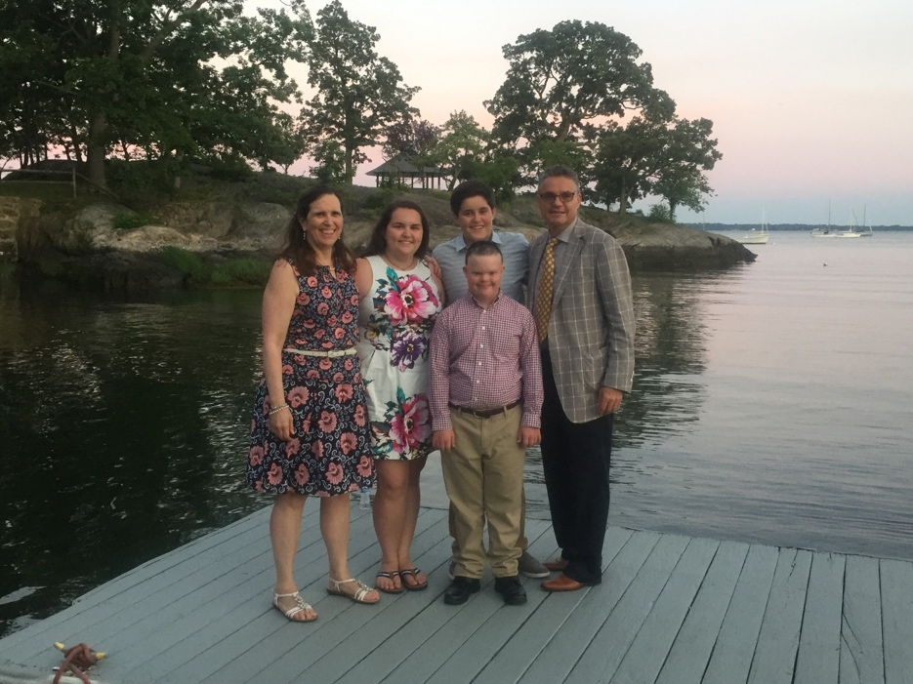
She grew up in Irvington-on-Hudson and is a graduate of the Choate Rosemary Hall school and Smith College, where she majored in Government. She also holds an associate degree in interior design from the New York School of Interior Design. She currently resides in Larchmont with her husband Rudolf and three children.

As a member of the Junior League of Westchester on the Sound (JLWOS), Alix was Chair of a committee in 1999 to explore whether there was a
need for a children's museum in Westchester. Market research conducted by the JLWOS showed resounding support among parents and educators for a children’s museum in this community and thus the Campaign for the Westchester Children's Museum was founded in 2001. Alix was a founding board member and has at various times served as Board Secretary, Vice President, and President, and continues today as Chair of the Exhibit Committee.
The Laager Family

Under her leadership, exhibit development began in 2003 with a workshop that included input from experts around the County in early childhood education, art, science, technology, cultural diversity, and universal design. This was followed by development of concepts, work with focus groups, and then the exhibition plans. Needless to say Alix is thrilled that the Museum is opening with exhibit experiences based on that early research.

In 2008 Alix and her husband Ruedi began working with the government of Bhutan to introduce education for children with special needs into their schools. Alix is the third generation of her family to be involved with development projects in Bhutan. Her experience as the parent of a child with special needs is at the core of her interest in helping Bhutan develop educational programs for children with special needs.

Alix has also been active with The Asia Society in New York as well as Larchmont Avenue Church. Most recently she has joined the board of the Mamaroneck Special Education PTA.

The Westchester Children’s Museum is honored to recognize Alix’s longstanding support and contributions to the development of this institution. It is with this in mind, that the Museum is proud to dedicate the Hoch Laager Boardwalk Gallery in the extended family’s honor.

